P4 – Carry out a structured analysis of a specified business process
Introduction
In this report, I will be carrying out a structured analysis to gathering information for a requirement specification. This is about a bespoke program for a plumbing job in order to help the business improve the current manual system. I will be producing a questionnaire and document analysis to gather information about this.

Questionnaire
Questionnaires are series of questions that are used to extract information for a particular topic. A questionnaire requires choices to tick off. The customer does not need to write paragraphs. They only tick off e.g. how old are you? ☒16-20.
They would be a box beside it, so they tick it off making it easier for everyone.

Advantage
The advantage of using questionnaire is that, in a short amount of time, large amounts of information can be found by using this method. This method is cost effective. Low costs and time would be used compared to others. You can choose who you want to give it out to. Specific audience can be chosen for this method. Any form of research can be used on this method. Having large amounts of information, they can analyse it and compare it later on. Another benefit is that it is up-to-date.

Disadvantage
The disadvantage of using questionnaire is that there is no way the user is telling the truth. Some people are going to be in a rush when you ask them, they will quickly rush the questionnaire. Enabling your research going to waste. These questions are going to be asked by the person who has created it. Giving it to a random person, who does not have a clue of what you are talking about, is a waste of time.

Questions
- What are the reasons for building this new program?
☐Updating the current system ☐ Errors ☐ other reason state here: ______________

- How many people use the current system?
☐1-10 ☐10-20 ☐20+

- How much are you willing to spend?
☐£0 - £500 ☐£500-£1000 ☐£1000+ State here exact amount: _____________

- When do you want the program to start?
State here exact date: __________________________________

- What operating system do you like to use?
☐Windows ☐MAC ☐any other state here: ______________
- What information do you get once get once the calculation is complete?
__________________________________________________________________________

___________________________________________________________________________
- What do you calculate?

- When do you want it to finish?
Exact date: _____________

- Do the user find the current system safe?
☐Yes ☐No
- Is it user friendly?
☐Yes ☐No

- How many receipts you do currently have?
☐0-10 ☐10-20 ☐20-30 ☐30+

- Do you have a computer?
☐Yes ☐No

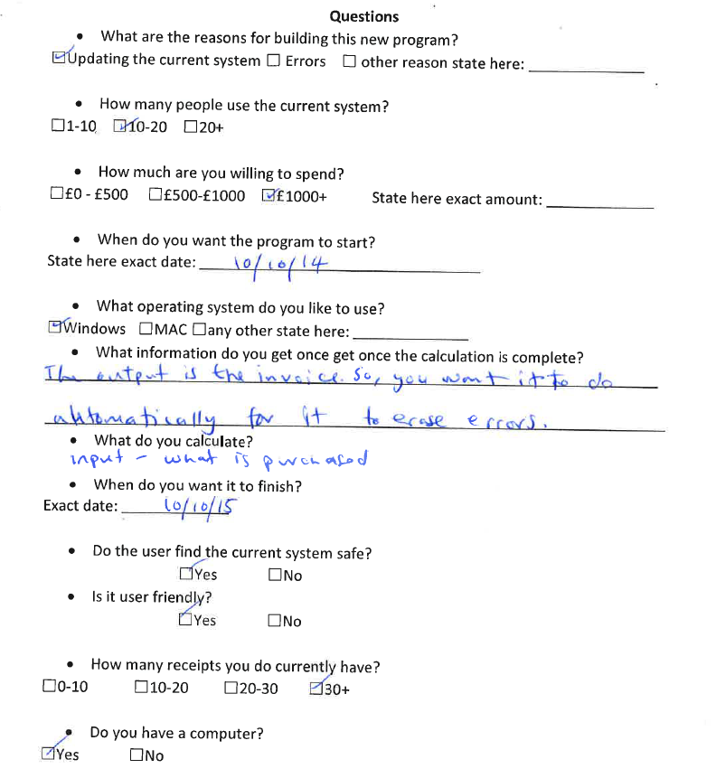
Questionnaire Result

Document Analysis
Document analysis is used to analyse research very detailed. All you do for this is ask for the all the invoices the company has used, and they will produce a detailed document analysis for you. It is not only one counts; they are many of the receipts.

Advantage & Disadvantage
The advantage of using document analysis does numerous of activities for this research method e.g. processing; analysing; and modelling data. Another benefit is that the outcome is usually valid and objective. This means it can usually give an insight of the difficult areas to work on. It is relatively low cost and the detail of the research is immense. Some are very detailed and long. Wherever you go, you can find a PC and do the document analysis on there. The disadvantage of using this method it is very time-consuming.

Fill in receipt
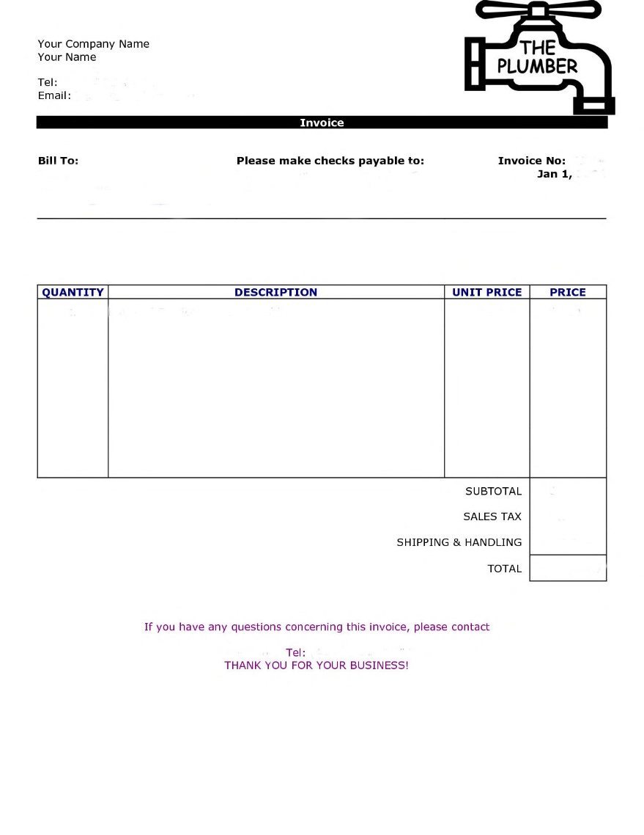
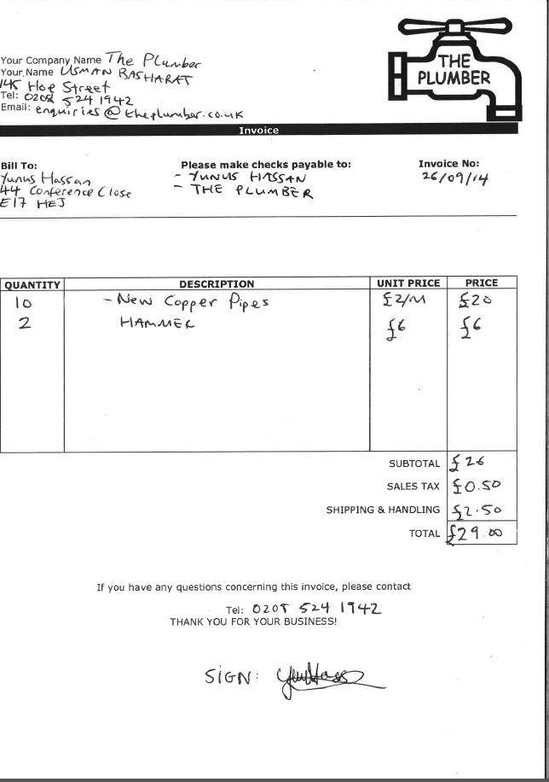
26.50
AFTER
BEFORE

Analysing Invoice
This is the companies address and all the details of it. Any enquires you have, you can contact them.
4) OTHER DETAILS
This symbol represents the plumber logo. This would be on every invoice that I would create.
4) OTHER DETAILS

Error
4) LAYOUT
6) Improvements
The improvements that I could make on this invoice is adding the calculation for the invoice that I’ve just made. Because this is made manually, I need to add the calculations. Also, I could add another section on the calculations part for the output. Another suggestion that I could make for this is the design. I think that I could add another section for each description on what it is going to do. Another suggestion is to make the ‘sign’ computerised to make it more professional. It would look better for it.
This is the exact date of when the invoice was written. It is important any person write the date, as they would get confused if not written.
4) OTHER DETAILS
This is the input that the user is going to put to calculate the cost.
1) INPUT
This is the output of the whole calculation. The total cost of how much it is going to cost.
3) OUTPUT
This is important to give away your telephone for any questions regarding this enquiry. Even if the business wants to continue supplying, you have to still have contact with the same number. If changed, state it.
4) OTHER DETAILS

26.50

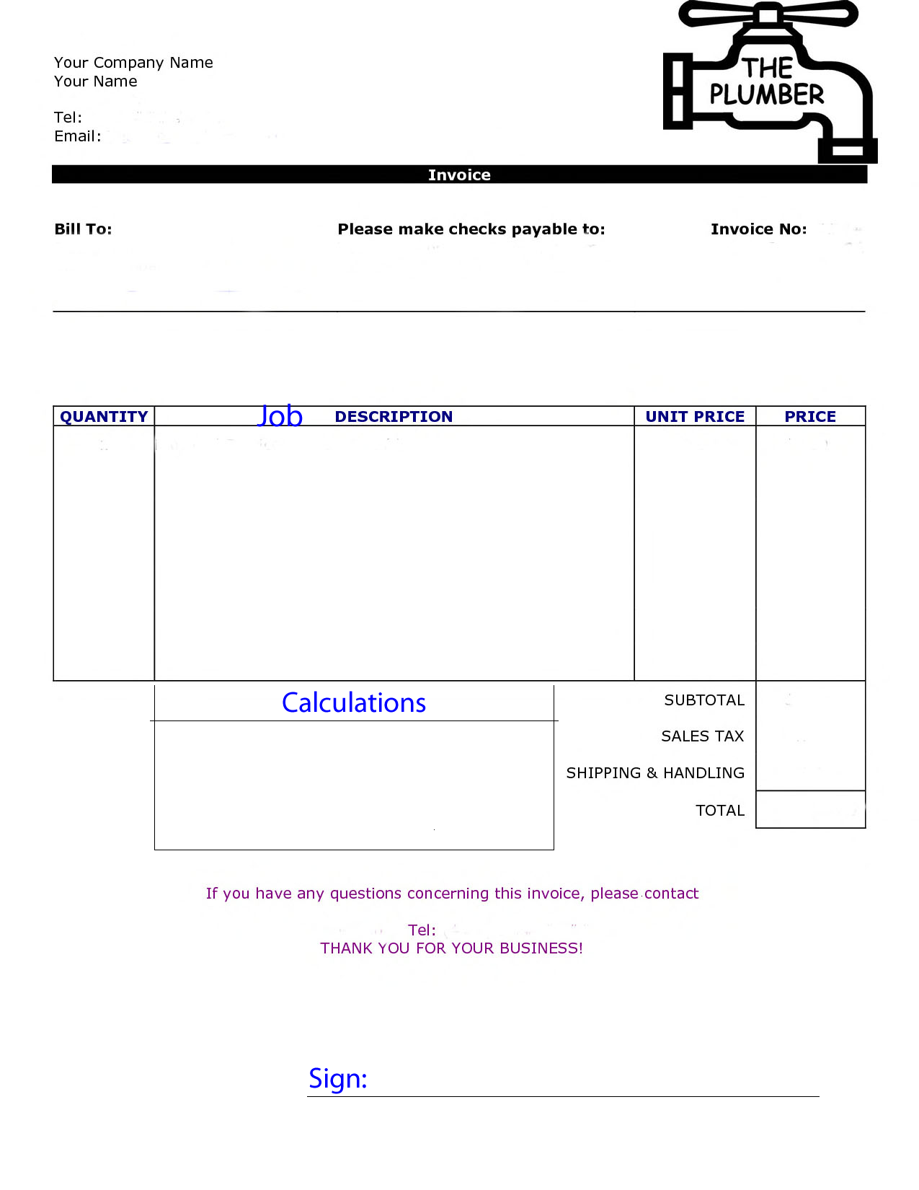
Design

